Tiffield Parish Council – Briefing Paper
Subject: Provision of Picnic Benches at Claydon Fields
Date: 13 April 2026
Author: Cllr Nichols
Purpose of Report
To seek approval from Tiffield Parish Council to purchase and install two picnic benches at Claydon Fields, located adjacent to the children’s playground.
Background
Claydon Fields is a well-used community green space, particularly by families with young children who utilise the playground facilities. At present, there is limited seating provision in close proximity to the play area.
This lack of seating restricts opportunities for:
- Parents and carers to comfortably supervise children
- Families to spend extended time at the site
- Community members to use the space for informal recreation (e.g. picnics)
Proposal
It is proposed that two heavy-duty round picnic benches are installed next to the children’s playground.
The recommended model is the Heavy Duty Supersized 8-Seater Excalibur Round Picnic Table, available here:
View product details
Key features:
- Seats up to 8 people per table, suitable for families and groups
- Commercial-grade construction, designed to withstand heavy public use
- Made from treated timber, offering durability for outdoor environments
- Space-efficient round design, ideal for communal seating
Benefits
The installation of picnic benches would deliver the following benefits:
- Improved accessibility and comfort: Provides seating for parents, carers, and older residents
- Enhanced community use: Encourages longer visits and informal social interaction
- Family-friendly environment: Supports inclusive use of the playground area
- Health and wellbeing: Promotes outdoor activity and community cohesion
- Value for money: Durable, long-lasting furniture suitable for public spaces
Financial Implications
- Approximate cost per bench: £443.33 (incl. VAT)
- Total cost for two benches: £886.66 (incl. VAT)
- Delivery and installation costs: [To be confirmed / estimated if required]
Bulk purchase discounts may be available for multiple units.
Location
The benches would be positioned adjacent to the children’s playground at Claydon Fields, ensuring clear visibility for supervision while maintaining safe spacing from play equipment.
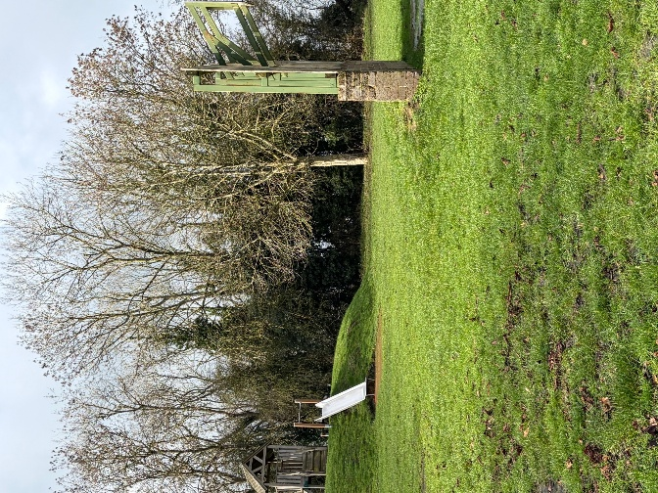

Risks & Considerations
- Ongoing maintenance requirements (minimal due to treated timber construction)
- Potential for misuse (mitigated through appropriate placement and durable design)
- Installation logistics (ground fixing may be required for safety)
Recommendation
That Tiffield Parish Council approves the purchase and installation of two picnic benches at Claydon Fields, at an estimated cost of £886.66 (incl. VAT), subject to confirmation of delivery and installation costs.

